# **Standard Operating Procedure (SOP) for Securely Mounting Best Gateway Devices on PLC Panels**

**Objective:** To ensure the proper installation and functioning of the Best Gateway Device within the PLC panel, following a systematic and secure procedure.

**Equipment and Components Required:**

**IIoT Component Setup**:

|  |  |  |  |
| --- | --- | --- | --- |
| Slno | Component Name | Image | Quantity |
| 1 | Best Gateway Device |  | 1 |
| 2 | SMPS,12v,5Amps |  | 1 |
| 3 | Electrical Tape |  | 1 |
| 4 | Cutter |  | 1 |
| 5 | Power Jack |  | 5 |
| 6 | Allen bolt, M3 |  | 5 |
| 7 | Tester |  | 1 |
| 8 | Multimeter |  | 1 |

**Components Required for Electrical Wiring and Installing the Best Gateway Device Inside the PLC Panel.**

|  |  |  |  |
| --- | --- | --- | --- |
| Slno | Component Name | Image | Quantity |
| 1. | Electrical wire |  | 20m |
| 2. | PLC Relay 24v |  | 4 |
| 3 | Relay Socket |  | 4 |
| 3. | Electrical tape |  | 1 |
| 4. | Drilling Machine |  | 1 |
| 5. | Wire cable |  | 20 |
| 6. | tester |  | 1 |

**Note**: We require an electrical person from the maintenance department to handle the wiring within the PLC panel.

1. **Verification of Outputs in PLC(5min)**

The electrician should first verify the availability of the four outputs in PLC:

* If the output is there, connect it to the relay.
* If the output is not present, inform the maintenance department to arrange the I/O module for the optimal gateway device.

2. **Mounting of SMPS and Relays(45min)**

-The electrician mounts the SMPS on the PLC panel, and the relay should also be mounted on the PLC panel. Power the SMPS using an MCB. Ensure that even if the machine turns off, the device remains powered. Refer to the diagram below for details fig-1.

Fig-1

3. **Mounting the Best Gateway Device(15min)**

-Mount the best gateway device on the PLC panel according to the dimensions of 250mm x 160mm.

* Horizontal case:

* Vertical case:

4. **Connecting Relays to PLC I/O Module(10min)**

The electrician connects the relay's terminals to the PLC I/O module. In our case, we have utilized a Mitsubishi Q Series PLC,(for reference, see Fig. 2 below).

Fig2-PLC I/O Module

5. **PLC Programming and IIoT Display Setup:(30min)**

* We require a PLC programmer to add the PLC logic based on the output. In our case, I have assigned Y70 for 'Start,' Y71 for 'OK,' Y72’ for 'NG,' and Y73’ for 'Reset’.
* After adding the PLC logic, create an IIoT display on the HMI. Inside the IIoT display, there should be four buttons for testing purposes: 1. Start, 2. OK, 3. NG, and 4. Reset(For reference, see Fig. 3 below).

Fig3 - HMI Display

**6.Relay Testing(5min)**

When we press the Start button on the HMI, the relay should turn on. Similarly, check all three relays when pressing the OK button, NG button, and Reset button(for reference, see Fig. 4 below).

Fig4-Relay

**7. Verifying Signal Pin with Multimeter(10min)**

After checking all the relays, proceed to test all four signals connected to the relay outputs:

* Start- I have connected the power jack to the multi-meter. When I press the Start button on the HMI display, the signal will read 24V on the multi-meter.
* OK- I have connected the power jack to the multi-meter. When I press the OK button on the HMI display, the signal will read 24V on the multi-meter.
* NG- I have connected the power jack to the multi-meter. When I press the NG button on the HMI display, the signal will read 24V on the multi-meter.
* Reset- I have connected the power jack to the multi-meter. When I press the Reset button on the HMI display, the signal will read 24V on the multi-
* meter.

**8. Ground Connection and Voltage Check(10min)**

- Connect the ground pin to the PLC's 0V terminal.

- Use a multimeter to verify the presence of 12V before powering on the Best Gateway Device.

**9. Powering On and Connecting I/O Ports:(5min)**

- Power on the Best Gateway Device.

- Connect I/O ports for 'Start,' 'OK,' 'NG,' 'Reset,' and ground pin.

**10. Manual Testing with Database(10min)**  
  
-After connecting all the connections on the best gateway, now check the device using the database(for reference, see Fig. 5 below).

1. To check if the OK part is complete, follow these steps:

* Click on the HMI display to access the IIoT section.
* Click the "Start" button.
* Click the "OK" button.
* Now, verify in the database whether the part has been marked as complete.

1. To check if the NG part is complete, follow these steps:

* Click on the HMI display to access the IIoT section.
* Click the "Start" button.
* Click the "OK" button.
* Now, verify in the database whether the part has been marked as complete.

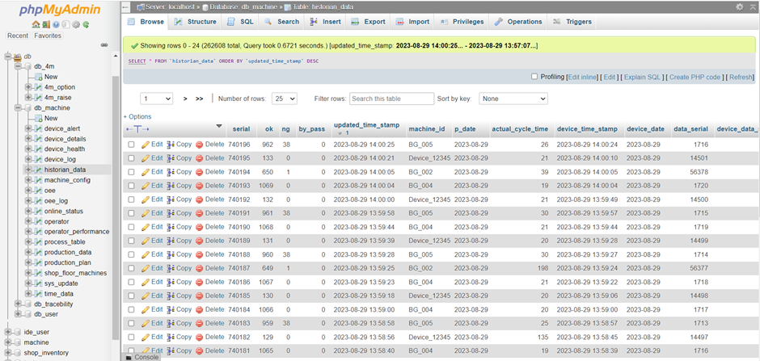

Fig5-Database Table

**11. Logic Integration with Machine Operation(30min)**

The PLC programmer connects the logic to the running conditions of the machine. For example, when the machine starts with the 'Start' button, it should connect our start logic accordingly. Similarly, they should connect the logic for 'OK,' 'NG,' and 'Reset' buttons. Additionally, a 2-second timer should be applied to each output.

**12. Final Testing with the Machine(20min)**

- Instruct the operator to start by creating the 'OK' part. After that, they should check if the data in the database is being recorded accurately. Once the 'OK' part is successfully made, proceed to test the 'NG' part. Ask the operator to create an 'NG' part and verify if the data is being correctly recorded in the databases (for reference, see Fig. 6 below).  
  
Fig6-Database Tables

**Note**: Safety precautions must be followed at all times during the installation process. Consult the relevant manuals and guidelines provided by the equipment manufacturers and your organization's safety protocols. Always involve qualified professionals for electrical work.